District of Sicamous  446 Main Street  PO Box 219  Sicamous, BC  V0E 2V0 | T: 250 836 2477  F: 250 836 4314  E: info@sicamous.ca  sicamous.ca
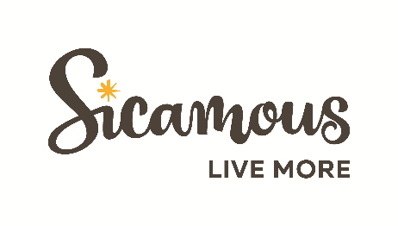

Sicamous is a thriving, diverse and beautiful four season community nestled in the natural beauty of the surrounding mountains, lakes and rivers. The community is the centre of recreation in the Shuswap and offers a unique and attractive place to live, work and play.

Competition Number: 14-2022

Job Title: Recreation Activity Leader

Position Type: Temporary

Expected Term: September 6 to June 28

Closing Date: Thursday, September 1, 2022

In compliance with Article 10.01 of the Collective Agreement, applications are invited by the undersigned up to 4:30 p.m. Thursday, September 1, 2022.
Under the direction of the Community Services Manager or designate, the Activity Leader will provide direct leadership, instruction, and supervision of recreational activities for children aged 5-12 years for the After School Kids Club. These activities may include, but are not limited to, outdoor recreation, arts, crafts, sports, games, music, dance, play and day trips.
As well, the Activity Leaders will provide supervision and oversight for evening recreational programming for all age groups.

Qualifications & Skills
- Current First Aid and CPR.
- Experience developing, promoting and leading recreation programs.
- Experience leading and supervising children aged 5-12 years.
- Customer service and public relations skills.
- Ability to stand, walk, squat and bend for prolonged periods.
- Ability to perform work in adverse weather conditions, including heat, cold and inclement weather.
- Ability to work independently and in a team environment.
- A clean and current criminal record check is a condition of employment and is the financial responsibility of the successful candidate.

Job Description: Available upon request.
Rate of pay: $21.14 in compliance with Schedule A of the CUPE 1908 Collective Agreement
Hours of work: Monday thru Friday 2:00 - 6:00 pm (excluding winter break and spring break). Longer shifts on Pro-D days, Spring Break, early school dismissal days and days where the District has evening recreation programming.

To explore this exciting opportunity, please email your cover letter and resume by September 1, 2022 at 4:30 p.m. to hr@sicamous.ca.

Posted this 29th day of August 2022

Copies: CUPE, Notice Board(s)

